**Question 1:**

**Image collection andsentimental analysis based on the imagetags using Instagramstreaming (related to your project)**

**a.Training Datasets:Instagram Streaming/Categorized Image (e.g., Static UEC Food Dataset) and meta data**

**b.Testing Datasetse.g., Image, UserGroup, Category, Rating(Instagramstreaming)**

Training Data Sets

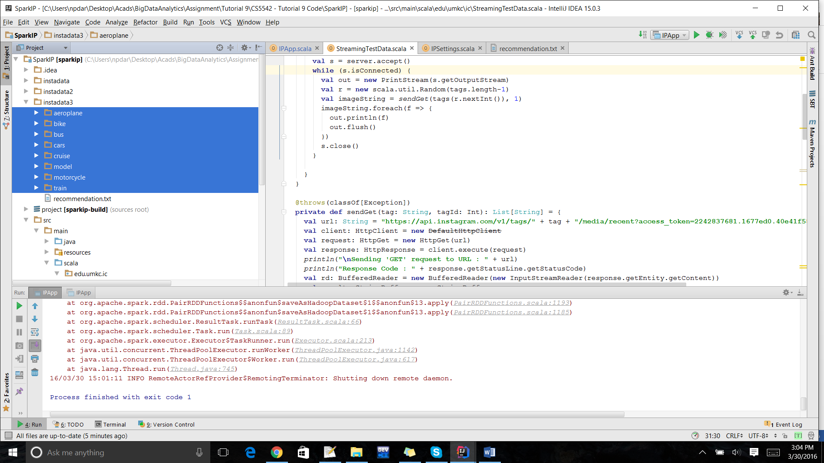

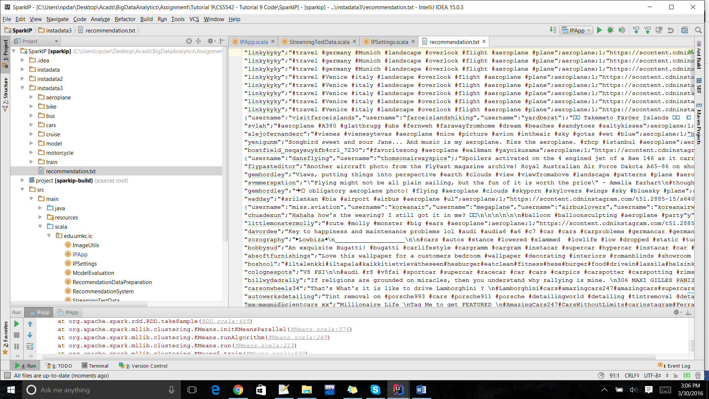

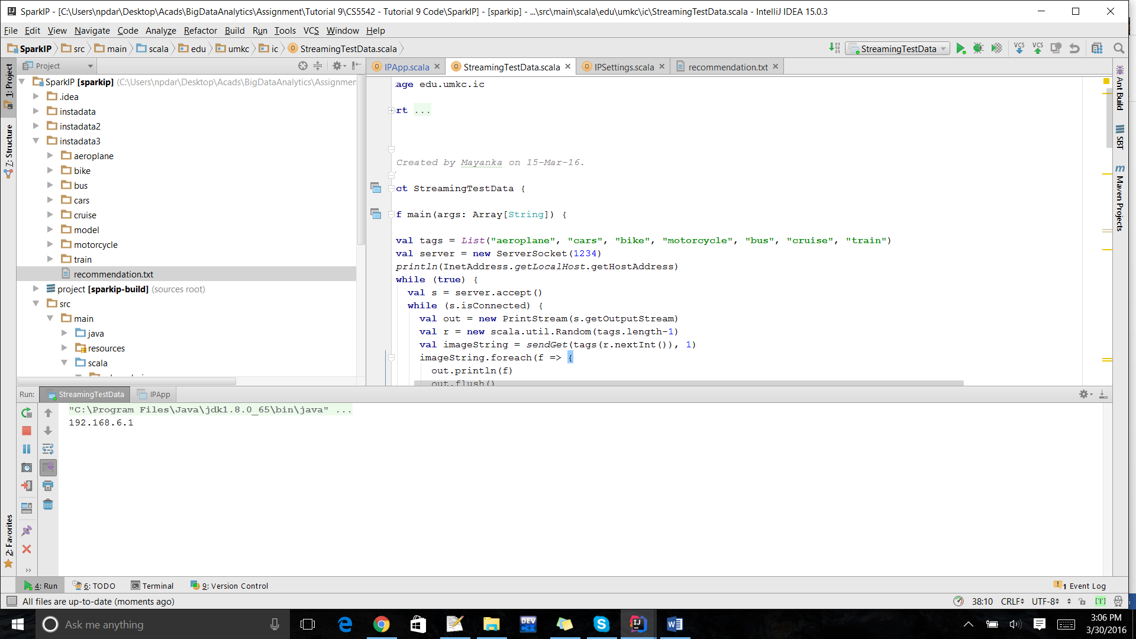

**Question 2:**

**Image Classification based on the categories related to your project**

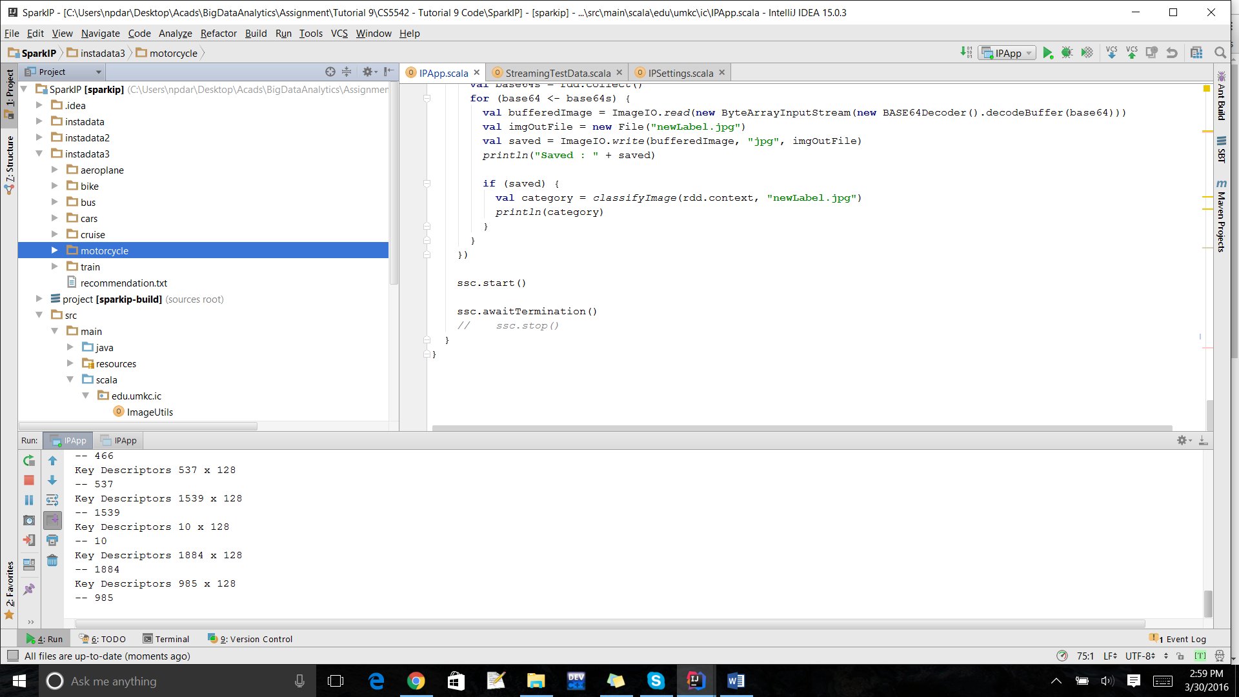

**Question 3:**

**Image-based Recommendation system(related to your own project)**

**a.Therating based on sentiment analysisof Instagrammetadata**

**b.Expected outcome is to make a recommendationbased on user image input or profile(e.g., preferences, location, gender, age)Key Descriptors – Feature Extraction**

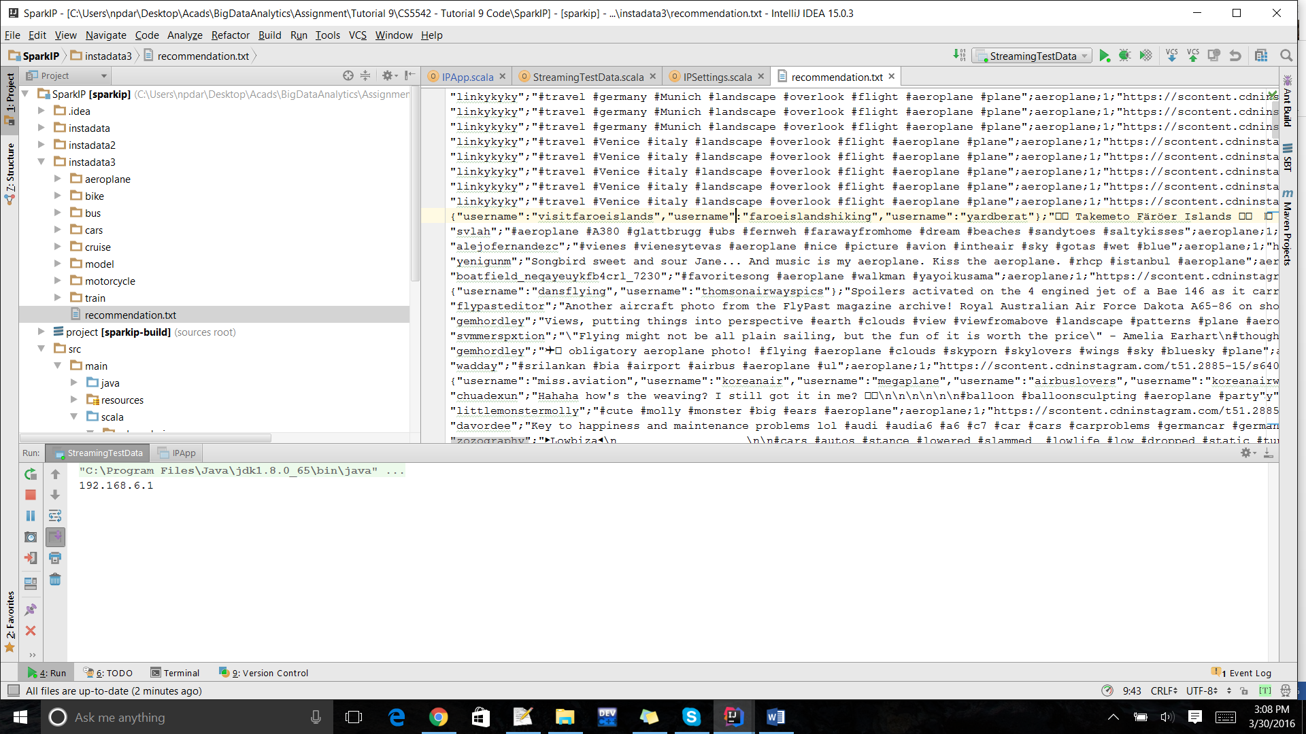

Recommendation System:

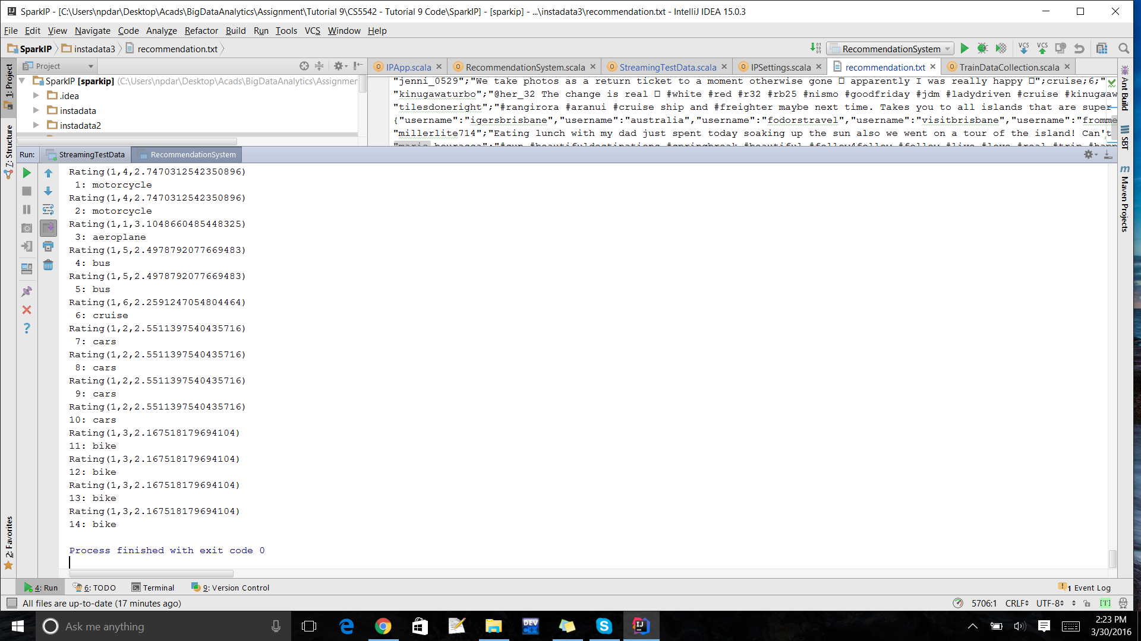

**Question 5:**

**MobileRecommendationthrough smartphone/smartwatchusing your ML application**

**Recommendation Snapshot**

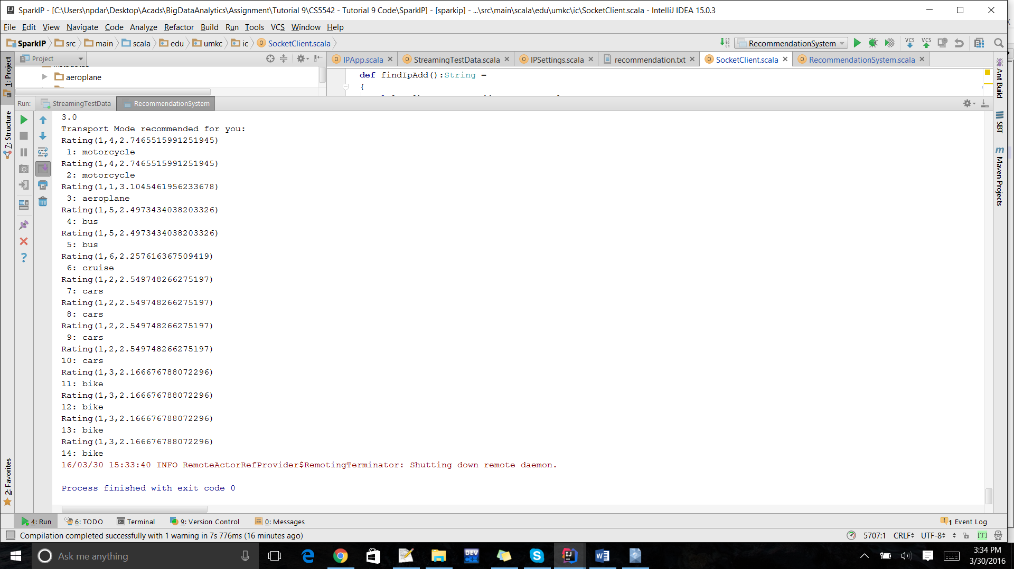

Notification about the recommendation to Mobile

